Planning Network-Based Firewall

# A Project Report

Submitted in the partial fulfillment of the requirements for the award of the degree of

# Bachelor of Technology in

Department of Computer Science and Engineering

By

E.Pravallika 2010030046

Tahseen Begum 2010030168

P.Keerthana 2010030445

under the supervision of

Dr. Gayathri Edamadaka



Department of Computer Science and Engineering

K L University Hyderabad,

Aziz Nagar, Moinabad Road, Hyderabad – 500 075, Telangana, India.

March 20

**Declaration**

The Project Report entitled “Planning Network-Based Firewalls” is a record of bonafide work of 2010030046 E.Pravallika, 2010030168 Tahseen Begum, 2010030445 P.Keerthana, submitted in partial fulfillment for the award of B.Tech in the Department of Computer Science and Engineering to the K L University, Hyderabad. The results embodied in this report have not been copied from any other Departments/universities/institutes.

Signature of the Students

**Certificate**

This is to certify that the Project Report entitled Planning Network-Based Firewall is being submitted by 2010030046 E.Pravallika, 2010030168 Tahseen Begum, 2010030445 P.Keerthana submitted in partial fulfillment for the award of B.Tech in Dr. Gayathri Edamadaka to the K L University, Hyderabad is a record of bonafide work carried out under our guidance and supervision.

The results embodied in this report have not been copied from any other departments/universities/institutes.

## Signature of the supervisor

## Signature of the HOD Signature of the External Examiner

**ACKNOWLEDGEMENT**

It is great pleasure for me to express my gratitude to our honorable President **Sri. Koneru Satyanarayana**, for giving the opportunity and platform with facilities in accomplishing the project-based laboratory report.

I express my sincere gratitude to our Principal **Dr. L. Koteswara Rao** for his administration of our academic growth.

I express sincere gratitude to our Coordinator for her leadership and constant motivation provided in the successful completion of our academic semester. I record it as my privilege to deeply thank you for providing us with the efficient faculty and facilities to make our ideas into reality.

I express my sincere thanks to our project supervisor **Dr.** **Gayathri Edamadaka**

for her novel association of ideas, encouragement, appreciation, and intellectual zeal which motivated us to venture into this project successfully.

Finally, it is pleased to acknowledge the indebtedness to all those who devoted themselves directly or indirectly to making this project report success.

Name: Tahseen Begum

Name: E.Pravallika

Name: Keerthana Pulugam

**ABSTRACT**

Network firewalls are security devices used to stop or mitigate unauthorized access to private networks connected to the Internet, especially intranets. The only traffic allowed on the network is defined via firewall policies – any other traffic attempting to access the network is blocked.

**TABLE OF CONTENTS**

|  |  |  |
| --- | --- | --- |
| S.No | Title | Page No |
| 1. | Introduction | 07 |
| 2. | Literature Survey | 08 |
| 3. | System Requirements | 09 |
| 4. | Functional and Non Functional Requirements4.1 Advantages and Disadvantages | 10 |
| 5. | Proposed System | 11 |
| 6. | Implementation | 12-14 |
| 7. | Result In discussion | 15 |
| 8. | Conclusion | 16 |
| 9. | Future work | 17 |
| 10. | Specific Contribution | 18 |
| 11. | References | 19 |

**INTRODUCTION**

Firewalls are expected to be part of the security of every computer system and network.

In its simplest implementation, a firewall will have a set of rules determining whether particular traffic should be allowed based on criteria like protocol, port, and source/destination IP address. The majority of firewalls will also have relatively strict rules blocking untrusted incoming traffic and relatively relaxed rules for outgoing traffic. By using such rules, we can restrict the exposure/visibility of services available on a particular computer to an untrusted network, eg the internet.

Today's networks change and develop regularly to adapt to new business situations, such as reorganizations, acquisitions, outsourcing, mergers, joint ventures, and strategic partnerships, and the increasing degree to which internal networks are connected internet. The increased complexity and openness of the network thus makes the question of security more complicated thither and necessity testes the development of sophisticated security technologies at the interface between networks between different security domains, such as between In Internet or Extranet. The best way of ensuring interface security is the use of a firewall.

• All traffic from inside to outside, and vice-versa, must pass through it.

• Only authorized traffic, as defined by the local security policy, is allowed to pass through it.

• The firewall itself is immune to penetration.

**LITERATURE SURVEY**

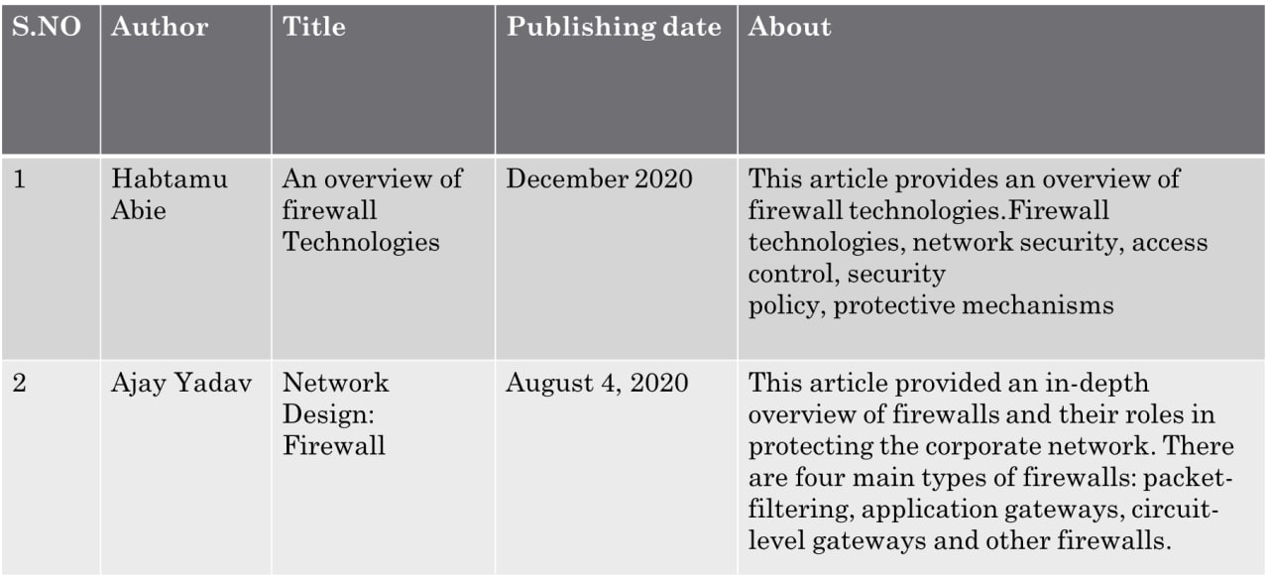

**SYSTEM REQUIREMENTS**

1. SOFTWARE REQUIREMENTS:

Operating system: Windows XP or later, Laptop, Mouse.

Tools: Cisco Packet tracer

1. HARDWARE REQUIREMENTS:

The hardware requirements that map towards the software are as follows:

RAM: 1007

Processor: Intel

**Functional & Non-functional requirements**

Functional requirements :

1. Controlling and Monitoring Data Packet Flow.
2. Become a Network Security Post.
3. Log User Activity.
4. Prevent Information Leakage.

Non-Functional requirements:

This non-functional requirement assures that all data inside the system or its part will be protected against malware attacks or unauthorized access.

Let’s take an example of a functional requirement. A system loads a webpage when someone clicks on a button. The related non-functional requirement specifies how fast the webpage must load. A delay in loading will create a negative user experience and poor quality of the system even though the functional requirement is fully met.

**Advantages and Disadvantages**

|  |  |
| --- | --- |
| **Advantages** | **Disadvantages** |
| 1. Monitors Traffic | 1. Server Resources Performance |
| 1. Prevents Hacker & Malware Injection | 2. Hardware Firewall is Higher Cost |
| 1. Access Control | 3. User Restrictions |
| 1. Software Firewall is Cost-Efficient | 4. Complex Operations |
| 1. Easy Installation | 5 Internal Networks Attacks |

**Proposed System**

**Cisco Packet Tracer** as the name suggests is a tool built by Cisco. This tool provides a network simulation to practice simple and complex networks.

Packet Tracer is a [cross-platform](https://en.wikipedia.org/wiki/Cross-platform) visual [simulation](https://en.wikipedia.org/wiki/Simulation) tool designed by [Cisco Systems](https://en.wikipedia.org/wiki/Cisco_Systems) that allows users to create [network topologies](https://en.wikipedia.org/wiki/Network_topologies) and imitate modern [computer networks](https://en.wikipedia.org/wiki/Computer_networks). The software allows users to simulate the configuration of Cisco routers and switches using a simulated command-line interface.

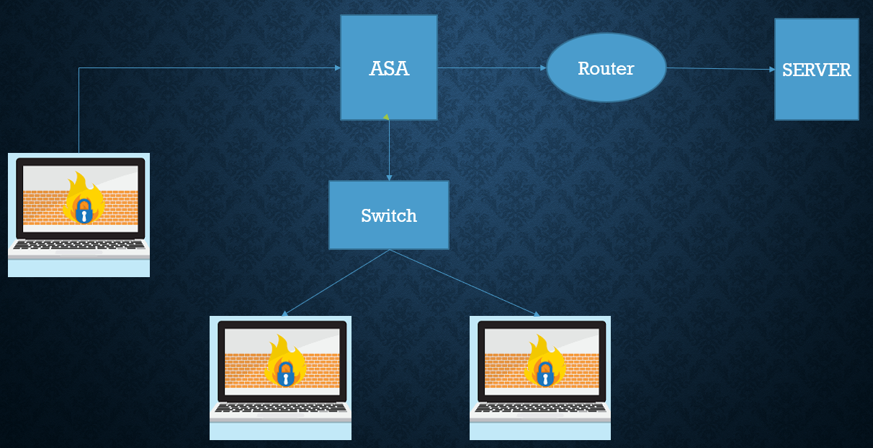

Fig no:1

**IMPLEMENTATION**

Configuration of Cisco ASA Firewall

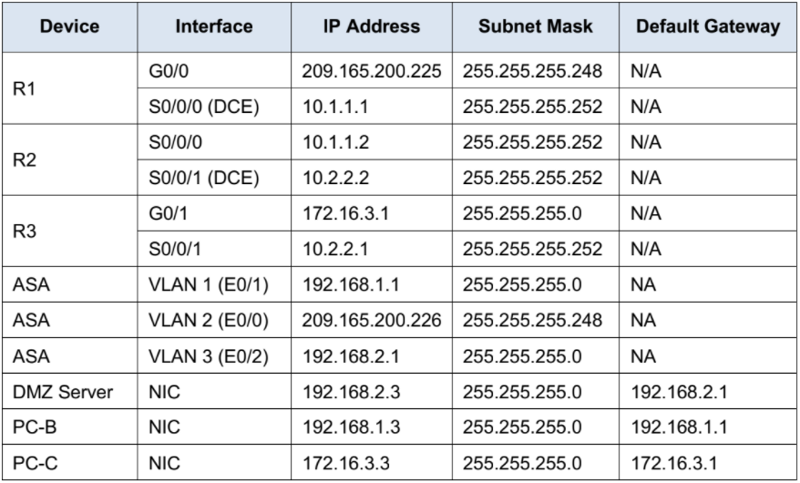

## Table no-1

Objectives

• Verify connectivity and explore the ASA

• Configure basic ASA settings and interface security levels using CLI

• Configure routing, address translation, and inspection policy using CLI

• Configure DHCP, AAA, and SSH

• Configure a DMZ, Static NAT, and ACLs

Scenario

Your company has one location connected to an ISP. R1 represents Customer Premises Equipment (CPE) device managed by the ISP. R2 represents an intermediate Internet router. R3 represents an ISP that connects an administrator from a network management company, who has been hired to remotely manage your network. The ASA is an edge CPE security device that connects the internal corporate network and DMZ to the ISP while providing NAT and DHCP services to inside hosts. The ASA will be configured for management by an administrator on the internal network and by the remote administrator. Layer 3 VLAN interfaces provide access to the three areas created in the activity: Inside, Outside, and DMZ. The ISP assigned the public IP address space of 209.165.200.224/29, which will be used for address translation on the ASA.

All router and switch devices have been preconfigured with the following:

o Enable password:

o Console password:

o Admin username and password:

Note: This activity provides additional practice and simulates most of the ASA 5505 configurations. When compared to a real ASA 5505, there may be slight differences in command output or commands that are not yet supported in Packet Tracer.

Packet Tracer - Configuring ASA Basic Settings and Firewall Using CLI

STEPS

Part 1: Verify Connectivity and Explore the ASA

Step 1: Verify connectivity.

The ASA is not currently configured. However, all routers, PCs, and the DMZ server are configured. Verify that PC-C can ping any router interface e.g R1 209.165.200.225. PC-C is unable to ping the ASA (209.165.200.226), PC-B (192.168.1.3), or the DMZ server(192.168.2.3).

Step 2: Determine the ASA version, interfaces, and license.

Use the show version command to determine various aspects of this ASA device. To enter the privileged mode of the ASA. Use the enable command to enter privileged mode on the ASA. Note: there is NO PASSWORD required to enter privileged mode. Press ENTER/RETURN key on the keyboard to move from user to privileged mode.

Step 3: Enter privileged mode.

a. Use the enable command to enter privileged mode on the ASA. Enter privileged EXEC mode. A password has not been set. Press Enter when prompted for a password.

Part 2: Configure ASA Settings and Interface Security Using the CLI

Tip: Many ASA CLI commands are similar to, if not the same, as those used with the Cisco IOS CLI. In

addition, the process of moving between configuration modes and sub-modes is essentially the same.

Step 1: Configure the hostname and domain name.

a. Configure the ASA hostname as ASA.

b. Configure the domain name as ciscosecurity.com

Step 2: Configure the enable mode password.

Use the enable password command to change the privileged EXEC mode password to ciscoenpa55.

Step 3: Set the date and time.

Use the clock set command to manually set the date and time.

Step 4: Configure the inside and outside interfaces.

Use the show interface IP brief command to see the state of the current interfaces.

You will only configure the VLAN 1 (inside) and VLAN 2 (outside) interfaces at this time. The VLAN 3 (DMZ) The interface will be configured in Part 5 of the activity.

a. Configure a logical VLAN 1 interface for the inside network (192.168.1.0/24) and set the security level to

the highest setting of 100.

ASA(config)# **interface VLAN 1**

ASA(config-if)# **nameif inside**

ASA(config-if)# **ip address 192.168.1.1 255.255.255.0**

ASA(config-if)# **security-level 100**

b. Create a logical VLAN 2 interface for the outside network (209.165.200.224/29), set the security level to

the lowest setting of 0, and enable the VLAN 2 interface.

ASA(config-if)# **interface VLAN 2**

ASA(config-if)# **nameif outside**

ASA(config-if)# **ip address 209.165.200.226 255.255.255.248**

ASA(config-if)# **security-level 0**

c. Use the following verification commands to check your configurations:

1) Use the show interface IP brief command to display the status for all ASA interfaces. Note: This

command is different from the IOS command showing the IP interface brief. If any of the physical or logical

interfaces previously configured are not up/up, troubleshoot as necessary before continuing.

Tip: Most ASA show commands, including ping, copy, and others, can be issued from within any

configuration mode prompt without the do command.

2) Use the show IP address command to display the information for the Layer 3 VLAN interfaces.

3) Use the show switch VLAN command to display the inside and outside VLANs configured on the ASA and to display the assigned ports.

Step 5: Test connectivity to the ASA.

An a. You should be able to ping from PC-B to the ASA inside interface address (192.168.1.1). If the pings fail, troubleshoot the configuration as necessary.

b. From PC-B, ping the VLAN 2 (outside) interface at IP address 209.165.200.226. You should not be able to ping this address.

Part 3: Configure Routing, Address Translation, and Inspection Policy

Using the CLI

Before you configure the static default route, view the current routing table.

Step 1: Configure a static default route for the ASA.

Configure a default static route on the ASA outside interface to enable the ASA to reach external networks.

a. Create a “quad zero” default route using the route command, associate it with the ASA outside interface,

and point to the R1 G0/0 IP address (209.165.200.225) as the gateway of last resort.

ASA(config)# **route outside 0.0.0.0 0.0.0.0 209.165.200.225**

b. Issue the show route command to verify the static default route is in the ASA routing table.

c.

d. Verify that the ASA can ping the R1 S0/0/0 IP address 10.1.1.1. If the ping is unsuccessful, troubleshoot as necessary.

Step 2: Configure address translation using PAT and network objects.

a. Create a network object inside-net and assign attributes to it using the subnet and nat commands.

ASA(config)# **object network inside-net**

ASA(config-network-object)# **subnet 192.168.1.0 255.255.255.0**

ASA(config-network-object)# **nat (inside,outside) dynamic interface**

ASA(config-network-object)# **end**

b. The ASA splits the configuration into the object portion that defines the network to be translated and the actual nat command parameters. These appear in two different places in the running configuration. Display the NAT object configuration using the show run command.

c. From PC-B attempt to ping the R1 G0/0 interface at IP address 209.165.200.225. The pings should fail.

d. Issue the show nat command on the ASA to see the translated and untranslated hits. Notice that, of the

pings from PC-B, four were translated and four were not. The outgoing pings (echos) were translated and sent to the destination. The returning echo replies were blocked by the firewall policy. You will configure the default inspection policy to allow ICMP in Step 3 of this part of the activity.

Step 3: Modify the default MPF application inspection global service policy.

For application layer inspection and other advanced options, the Cisco MPF is available on ASAs.

The Packet Tracer ASA device does not have an MPF policy map in place by default. As a modification, we can create the default policy map that will perform the inspection on inside-to-outside traffic. When configured correctly only traffic initiated from the inside is allowed back into the outside interface. You will need to add ICMP to the inspection list.

a. Create the class-map, policy-map, and service-policy. Add the inspection of ICMP traffic to the policy map

list using the following commands:

ASA(config)# **class-map inspection_default**

ASA(config-cmap)# **match default-inspection-traffic**

ASA(config-cmap)# **exit**

ASA(config)# **policy-map global_policy**

ASA(config-pmap)# **class inspection_default**

ASA(config-pmap-c)# **inspect icmp**

ASA(config-pmap-c)# **exit**

ASA(config)# **service-policy global_policy global**

b. From PC-B, attempt to ping the R1 G0/0 interface at IP address 209.165.200.225. The pings should be successful this time because ICMP traffic is now being inspected and legitimate return traffic is being allowed. If the pings fail, troubleshoot your configurations.

c.

Part 4: Configure DHCP, AAA, and SSH

Step 1: Configure the ASA as a DHCP server.

a. Configure a DHCP address pool and enable it on the ASA inside interface.

ASA(config)# **dhcpd address 192.168.1.5-192.168.1.36 inside**

b. (Optional) Specify the IP address of the DNS server to be given to clients.

ASA(config)# **dhcpd DNS 8.8.8.8 interface inside**

c. Enable the DHCP daemon within the ASA to listen for DHCP client requests on the enabled interface (inside).

ASA(config)# **dhcpd enable inside**

d. Change PC-B from a static IP address to a DHCP client, and verify that it receives IP addressing

information. Troubleshoot, as necessary to resolve any problems.

e.

Step 2: Configure AAA to use the local database for authentication.

a. Define a local user named admin by entering the username command. Specify a password of

adminpa55.

ASA(config)# **username admin password adminpa55**

b. Configure AAA to use the local ASA database for SSH user authentication.

ASA(config)# **aaa authentication ssh console LOCAL**

Step 3: Configure remote access to the ASA.

The ASA can be configured to accept connections from a single host or a range of hosts on the inside or

outside the network. In this step, hosts from the outside network can only use SSH to communicate with the ASA.

SSH sessions can be used to access the ASA from the inside network.

a. Generate an RSA key pair, which is required to support SSH connections. Because the ASA device has RSA keys are already in place, enter no when prompted to replace them.

ASA(config)# **crypto key generate RSA modulus 1024**

WARNING: You have an RSA keypair already defined named <Default-RSA-Key>.

Do you want to replace them? [yes/no]: no

ERROR: Failed to create new RSA keys named <Default-RSA-Key>

b. Configure the ASA to allow SSH connections from any host on the inside network (192.168.1.0/24) and the remote management host at the branch office (172.16.3.3) on the outside network. Set the SSH timeout to 10 minutes (the default is 5 minutes).

ASA(config)# **ssh 192.168.1.0 255.255.255.0 inside**

ASA(config)# **ssh 172.16.3.3 255.255.255.255 outside**

ASA(config)# **ssh timeout 10**

c. Establish an SSH session from PC-C to the ASA (209.165.200.226). Troubleshoot if it is not successful.

PC> **ssh -l admin 209.165.200.226**

d. Establish an SSH session from PC-B to the ASA (192.168.1.1). Troubleshoot if it is not successful.

PC> **ssh -l admin 192.168.1.1**

Note: if this doesn’t work, ensure you have set the domain name as ciscosecurity.com in Part 2 above. Use the SSH command (shown below) from PC-B or PC-C.

Part 5: Configure a DMZ, Static NAT, and ACLs

R1 G0/0 and the ASA outside interface already use 209.165.200.225 and .226, respectively. You will use public address 209.165.200.227 and static NAT to provide address translation access to the server.

Step 1: Configure the DMZ interface VLAN 3 on the ASA.

a. Configure DMZ VLAN 3, which is where the public access web server will reside. Assign it an IP address

192.168.2.1/24, name it DMZ, and assign it a security level of 70. Because the server does not need to initiate communication with the inside users, disable forwarding to interface VLAN 1.

ASA(config)# **interface VLAN 3**

ASA(config-if)# **ip address 192.168.2.1 255.255.255.0**

ASA(config-if)# **no forward interface vlan 1**

ASA(config-if)# **nameif dmz**

INFO: Security level for "DMZ" set to 0 by default.

ASA(config-if)# **security-level 70**

b. Assign ASA physical interface E0/2 to DMZ VLAN 3 and enable the interface.

ASA(config)# **interface Ethernet0/2**

ASA(config-if)# **switchport access VLAN 3**

c. Use the following verification commands to check your configurations:

1) Use the show interface IP brief command to display the status for all ASA interfaces.

2) Use the show IP address command to display the information for the Layer 3 VLAN interfaces.

3) Use the show switch VLAN command to display the inside and outside VLANs configured on the ASA and to display the assigned ports.

Step 2: Configure static NAT to the DMZ server using a network object.

Configure a network object named DMZ-server and assign it the static IP address of the DMZ server

(192.168.2.3). While in object definition mode, use the nat command to specify that this object is used to translate a DMZ address to an outside address using static NAT, and specify a public translated address of 209.165.200.227.

ASA(config)# **object network dmz-server**

ASA(config-network-object)# **host 192.168.2.3**

ASA(config-network-object)# **nat (dmz,outside) static 209.165.200.227**

ASA(config-network-object)# **exit**

Step 3: Configure an ACL to allow access to the DMZ server from the Internet.

Configure a named access-list OUTSIDE-DMZ that permits the TCP protocol on port 80 from any external

host to the internal IP address of the DMZ server. Apply the access list to the ASA outside interface in the “IN”

direction.

ASA(config)# **access-list OUTSIDE-DMZ permit ICMP any host 192.168.2.3**

ASA(config)# **access-list OUTSIDE-DMZ permit TCP any host 192.168.2.3 eq 80**

ASA(config)# **access-group OUTSIDE-DMZ in interface outside**

Note: Unlike IOS ACLs, the ASA ACL permit statement must permit access to the internal private DMZ address. External hosts access the server using its public static NAT address, the ASA translates it to the internal host IP address and then applies the ACL.

Step 4: Test access to the DMZ server.

Test outside access to the DMZ - launch a ping test to the DMZ server to check for connectivity. Then, try and get to the webserver from PC-C.

References: Cisco Networking Academy – Please note this exercise has been modified

from the original to add in extra step-by-step images.

**RESULT IN DISCUSSION**

## 

• Verify connectivity and explore the ASA.

• Configure basic ASA settings and interface security levels using CLI.

• Configure routing, address translation, and inspection policy using CLI.

• Configure DHCP, AAA, and SSH.

• Configure a DMZ, Static NAT, and ACLs.

R2 represents an intermediate Internet router. R3 represents an ISP that connects an administrator from a network management company, who has been hired to remotely manage your network. The ASA is an edge CPE security device that connects the internal corporate network and DMZ to the ISP while providing NAT and DHCP services to inside hosts. The ASA will be configured for management by an administrator on the internal network and by the remote administrator. Layer 3 VLAN interfaces provide access to the three areas created in the activity: Inside, Outside, and DMZ. The ISP assigned the public IP address space of 209.165.200.224/29, which will be used for address translation on the ASA.

**CONCLUSION**

Some form of security for private networks connected to the internet is essential. A firewall is an important and necessary part of that security, but cannot be expected to perform all the required security functions.

Limitations:

* Firewalls cannot stop users from accessing malicious websites, making it vulnerable to internal threats or attacks.
* Firewalls cannot protect against the transfer of virus-infected files or software.
* Firewalls cannot prevent misuse of passwords.
* Firewalls cannot protect if security rules are misconfigured.
* Firewalls cannot protect against non-technical security risks, such as social engineering.
* Firewalls cannot stop or prevent attackers with modems from dialing in to or out of the internal network.
* Firewalls cannot secure the system which is already infected.

**FUTURE WORK**

Firewalls will continue to advance as the attacks on the IT industry and infrastructure become more and more sophisticated. Firewalls that scan for viruses as they enter the network and several firms are currently exploring this idea, but it is not yet in wide use.

**Specific Contribution**

A firewall can help protect your computer and data by managing your network traffic. It does this by blocking unsolicited and unwanted incoming network traffic. A firewall validates access by assessing this incoming traffic for anything malicious like hackers and malware that could infect your computer.

**REFERENCE**

[1] Tang Xiao bin. Computer Network Security Research [J] Based on Firewall Technology Digital World, 2018(07): 38.

[2] Gu Kui ye, Liu Fa sheng. Analysis of Computer Network Security Governance and Firewall Technology [J].] in China Electronic Testing, 2016(22): 63-64.

[3] Wang Qiangqiang. Analysis of Application of Firewall-based Technology in Computer

Security Construction [J] of China Digital World, 2019(08): 244.

[4] Road race. Countermeasure Research on Strengthening Computer Network Security

Management in the Background of E-Commerce, SME Management, and Technology

(Mid-Year Journal), 2020 (08): 39-40.

[5] Peng Zhen yu. Based on computer network security and preventive countermeasures research,

cyber security technology and application, 2020 (08): 3-4.

[6] Zhang Rui Computer Network Security and Firewall Technology Analysis [J] Computer

Knowledge and Technology, 2012(24): 5787-5788.